**CMPE 273: Enterprise Distributed Systems**

**Lab -1 Assignment**

**Etsy Website using Rest and ReactJs**

**Project YouTube Link:** [**https://youtu.be/AjE8OObq0SA**](https://youtu.be/AjE8OObq0SA)

**INTRODUCTION:**

**GOAL:**

To develop a mock of Etsy E-Commerce Website using Node.js in the backend and React.js in the frontend. MySQL database is used to manage the maintain the user, user profile, shops and items per shop. Some actions which can be performed include storing the user details, updating the user details, adding a new shop and placing orders for various items present in different shops.

The application mainly allows the user to create a new profile and add a shop suing which he can display various items and can sell them as well. It is like an e-commerce website which allows one to view, sell and update items. It is basically connecting a buyer to a seller. The application should allow new users to register, add a shop, list various products and sell their products to the buyer.

**PURPOSE:**

Following tasks will be carried out by the Etsy application:

1. Users (Shop Owner/Customer)

Page – Login, Landing Page

* A new user (first timer) can sign up on to the application or an already existing user can log in / log out into his account.
* Every user has a dedicated Dashboard Page on Logging In to his account wherein all the previously added shops and items would be displayed. He /She can create a new shop and start adding items to it.
* Every user would have an option to update their profile page wherein field like date of birth, country, city, e-mail, address can be updated.
* Users can add new items to their respective shops also edit the shops i.e., change the image, category, price, quantity.
* The logged in user can also view the items from another user’s shop and buy the items, i.e., add to cart or add to Wishlist.
* The ‘add to Wishlist’ option allows the users to shortlist their favorite products which they can store and re-visit later on.

2) Dashboard

* The Dashboard page would display various options available to the logged in user like – Favorite Page, Add Shop, View Shop page, Cart and My Purchase page. The user can easily access one of these pages and view the required information.
* The Dashboard page mainly displays all the items along with its respective picture, quantity, category, and shop name.
* The user can view all the items added in different shops, place an order (cart page).

3) Add Shop

* The Add shop Page would allow the user to add a new shop, update the shop image. Also prior to this the shop name would be checked, if its unique then only a shop would get added.
* Upon successful creation of a shop, the user can add items and specify the name, category, quantity and price as well.
* The logged in user can only view, edit or update his shop and not another user shop page.

4.) View/Edit Shop

* After creating a shop, the user can view and update the shop details like picture, name.
* The user can also edit or add items to his/her shop.

5.) Favorite Page

* The user can add various items from different shops to the favorite page. In this page all the details like quantity, price, image of the particular shop gets stored. The user can view his favorite items at any given point of time and can remove them as well.

6) Cart

* A user can add items from various pages to the cart and checkout.
* In the cart page the item along with its name, shop, quantity (set by the user) and the total amount would be displayed.
* The user has an option to delete an item from the cart or update the quantity, upon this the respective price would be calculated and displayed.

7.) My Purchase Page / Summary

* A detailed summary of all the items purchased by the user would be displayed along with its price, image, category.
* It is like a receipt page which displays the purchases made by the user.

Other functionalities include Contact Page

**SYSTEM DESIGN:**

The Etsy application allows the user to add unique shops. Once the shop is created the user can add items/products to it along with details like category, price, quantity, name. Once the shop and items to the respective shop is added the user can still update the shop details and item details.

For the server side NodeJS is used, backend is written in MySQL and for the frontend React Js is used.

When a user executes a query or gives an input, in the system the frontend React Js makes a call to the backend Node Js server which fetches the call to the NodeJS server which fetches the call to the NodeJS server which fetch the calls and it is posted in the database. ReactJS makes the requests to the backend and the NodeJS receives the requests makes database queries and it inserts, update or gets the data. Specific routes are used for posting and fetching all the data (api calls)

Validation and error exceptions are done for every function. Session management has been done by using cookies.

Brief Overview:

1. ReactJS uses routes to make get, post calls to express backend.
2. NodeJS receives the requests from the frontend and then it makes database queries to get data, update and insert data.
3. CRUD operations on the database are performed by the MYSQL after NodeJS requests.
4. After database performs its operation backend sends the results to the frontend ReactJS and then it displays the data

**SCREENSHOTS OF THE APPLICATION:**

1)Login Page:

* This is the starting page of the application from here user can go to login page or signup page
* Upon successful logging in the user would get redirected to the Dashboard Page

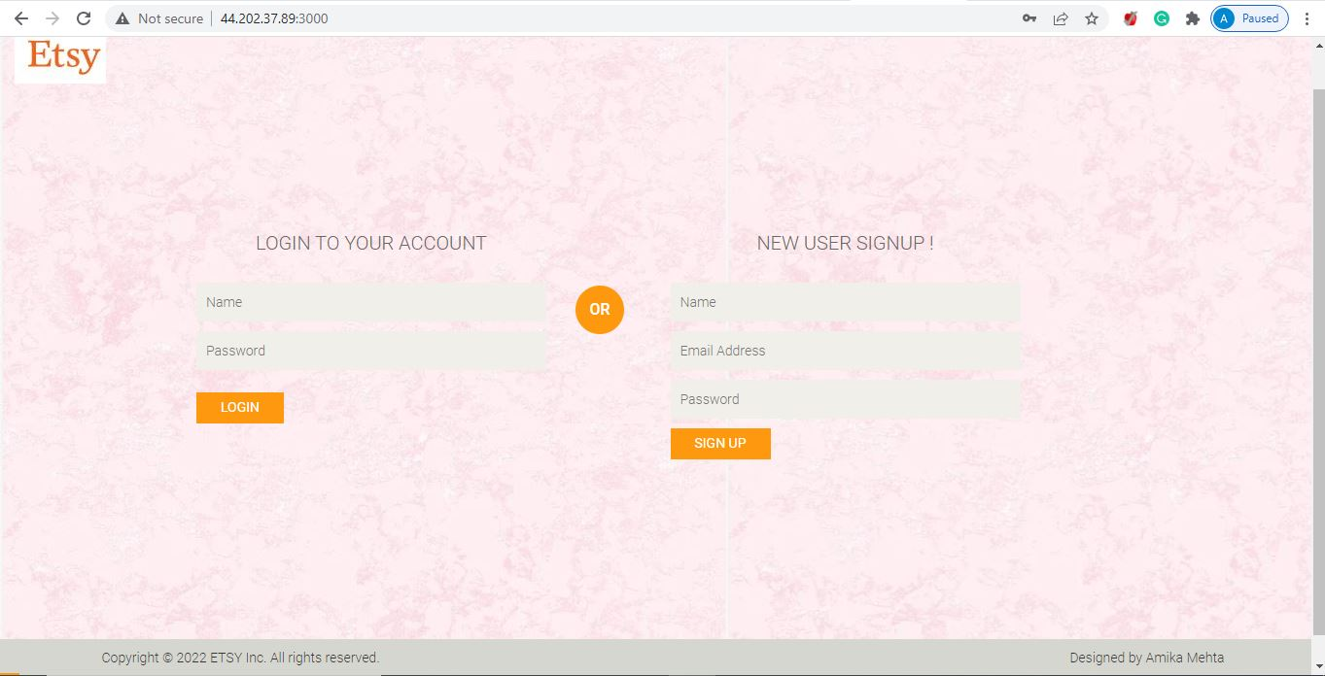

1. Dashboard Page

Upon successful logging in the user can view various options available to him/her: Add Shop, View Shop, Items.

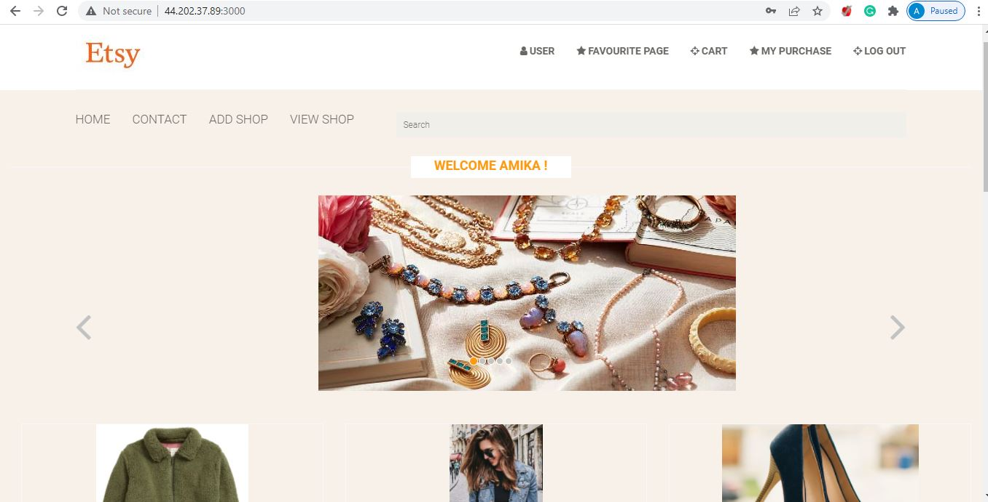

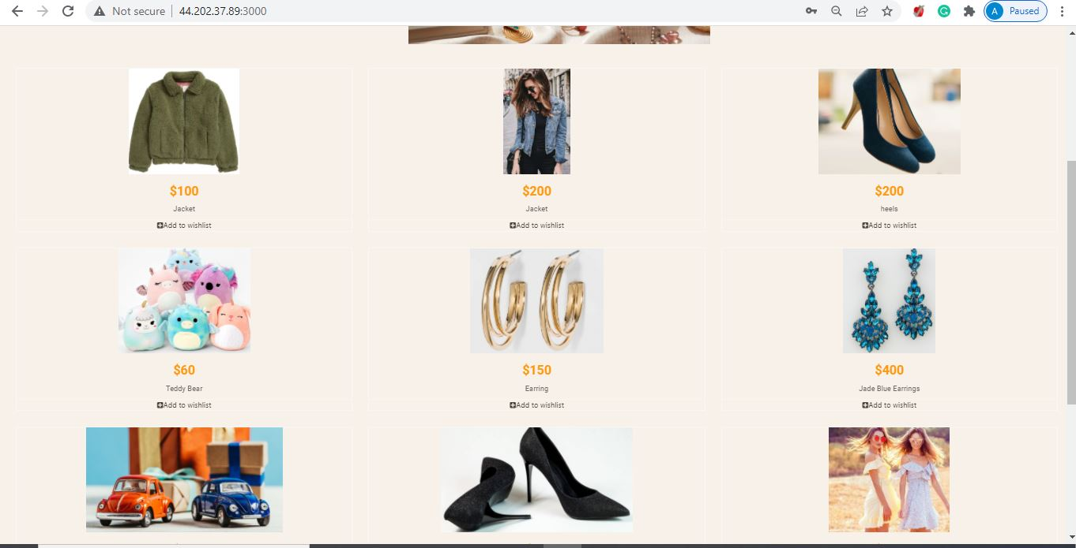

1. Add Shop Page

The user can add a new shop and can start listing and selling his products.

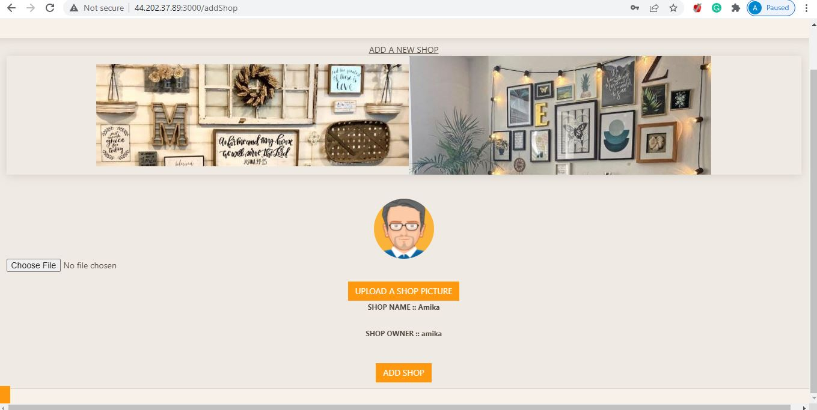

1. Add Item Page

Once the shop is created the user can start building his shop, i.e., list various items with fields like category, price, name.

In order to take in the inputs a pop-up form would be displayed.

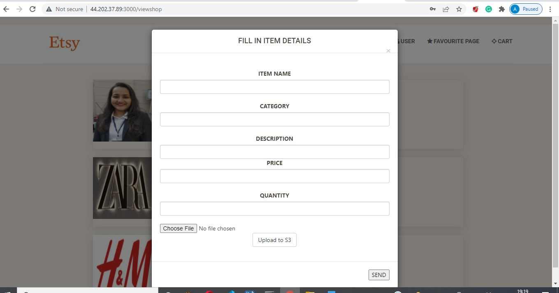

1. View Item Page

The user can review all the items he/she has added so far in the shop and also make changes to the items, edit name, image, quantity.

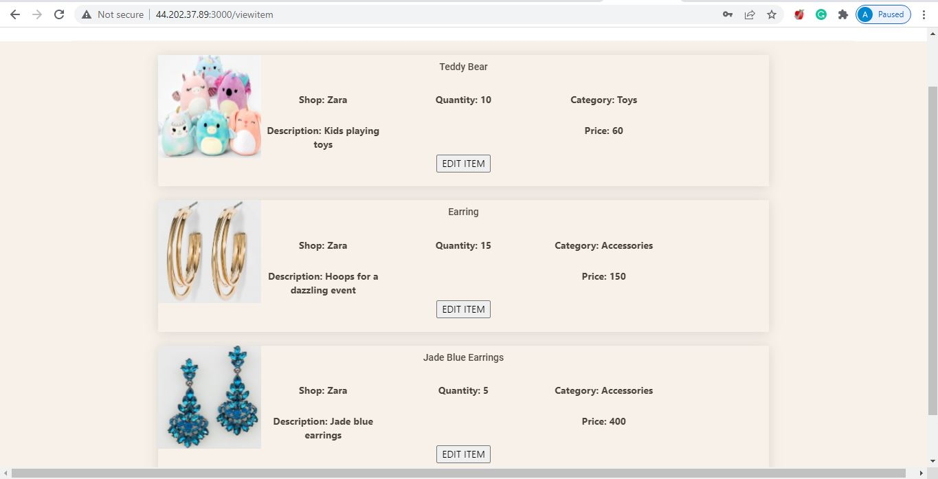

1. **Cart Page**

The user can add all the items he wishes to purchase to the cart. All the items would get added to cart along with their shop name, item name, price.

The user can edit the quantity of the item and would get a total price accordingly.

If an item is out of stock an alert would get generated.

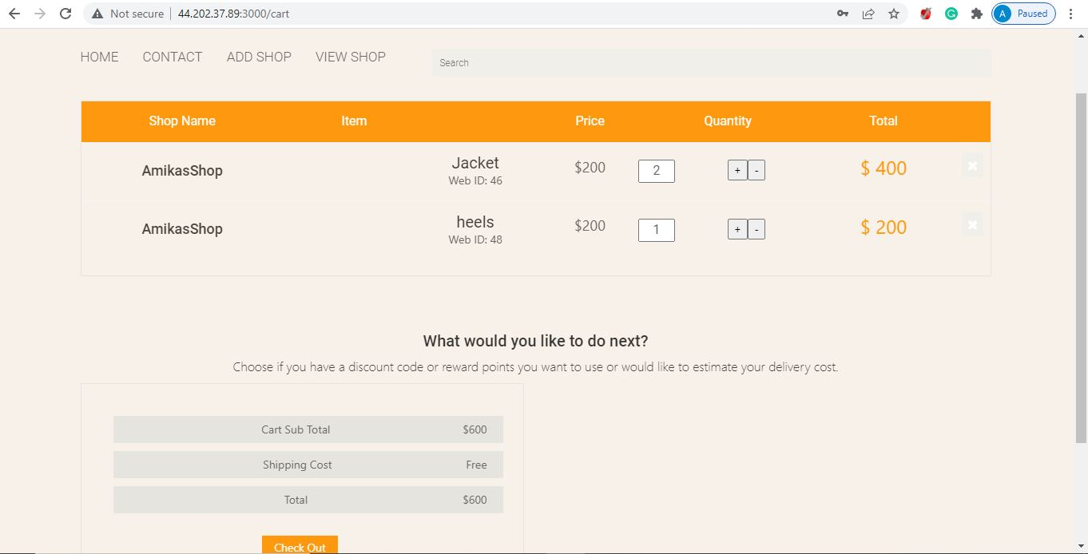

1. Purchase Page

A summary page displaying all the items purchased by the user would get displayed here.

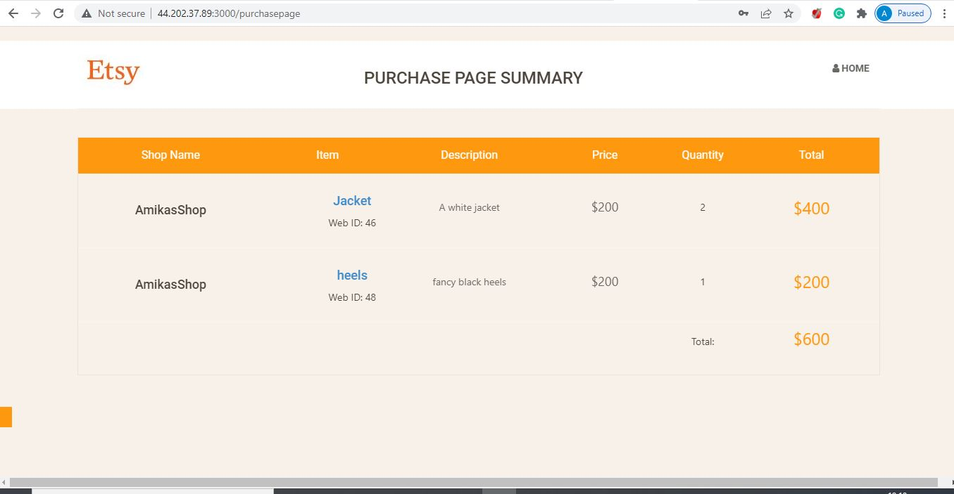

1. Upload Profile Page

The user can update his profile page and change his date of birth, city, country.

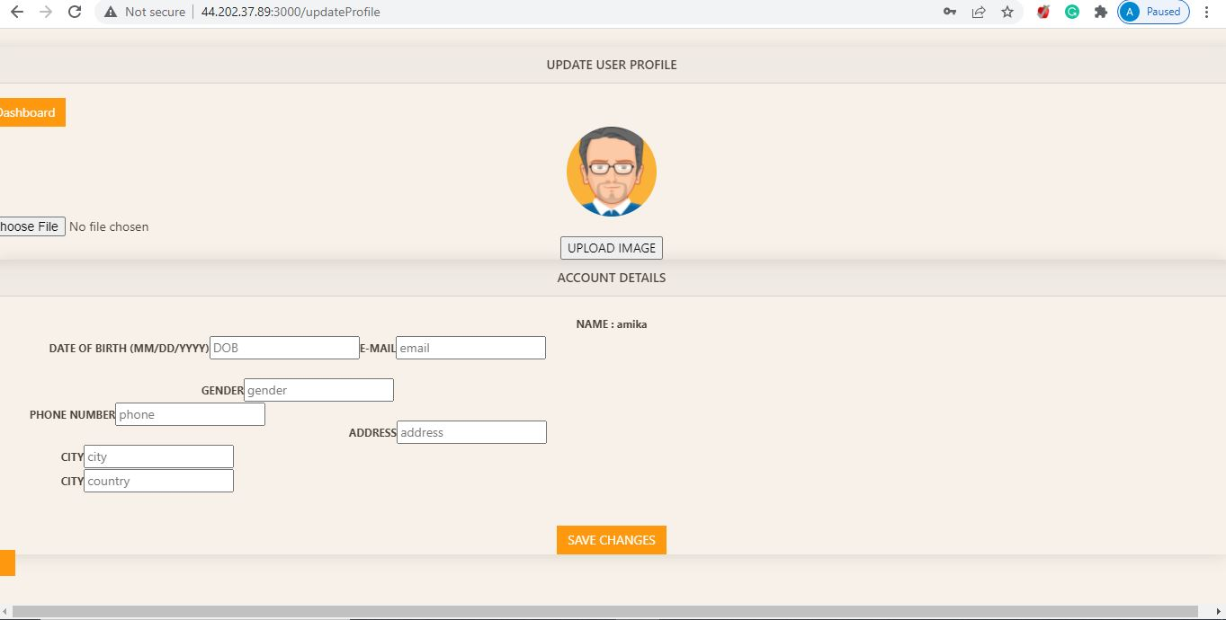

1. Shopping Overview Page

The user before adding a particular product to the cart can view the details of the product, set its quantity and thus proceed to checkout.

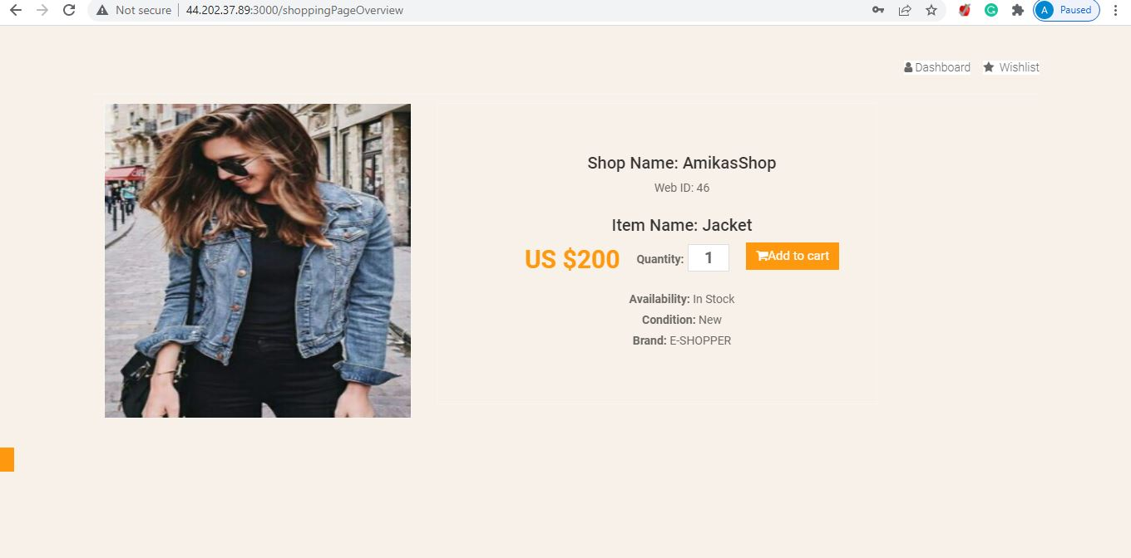

**JMeter Testing**

**Without Pooling**

1. **With 100 concurrent users**

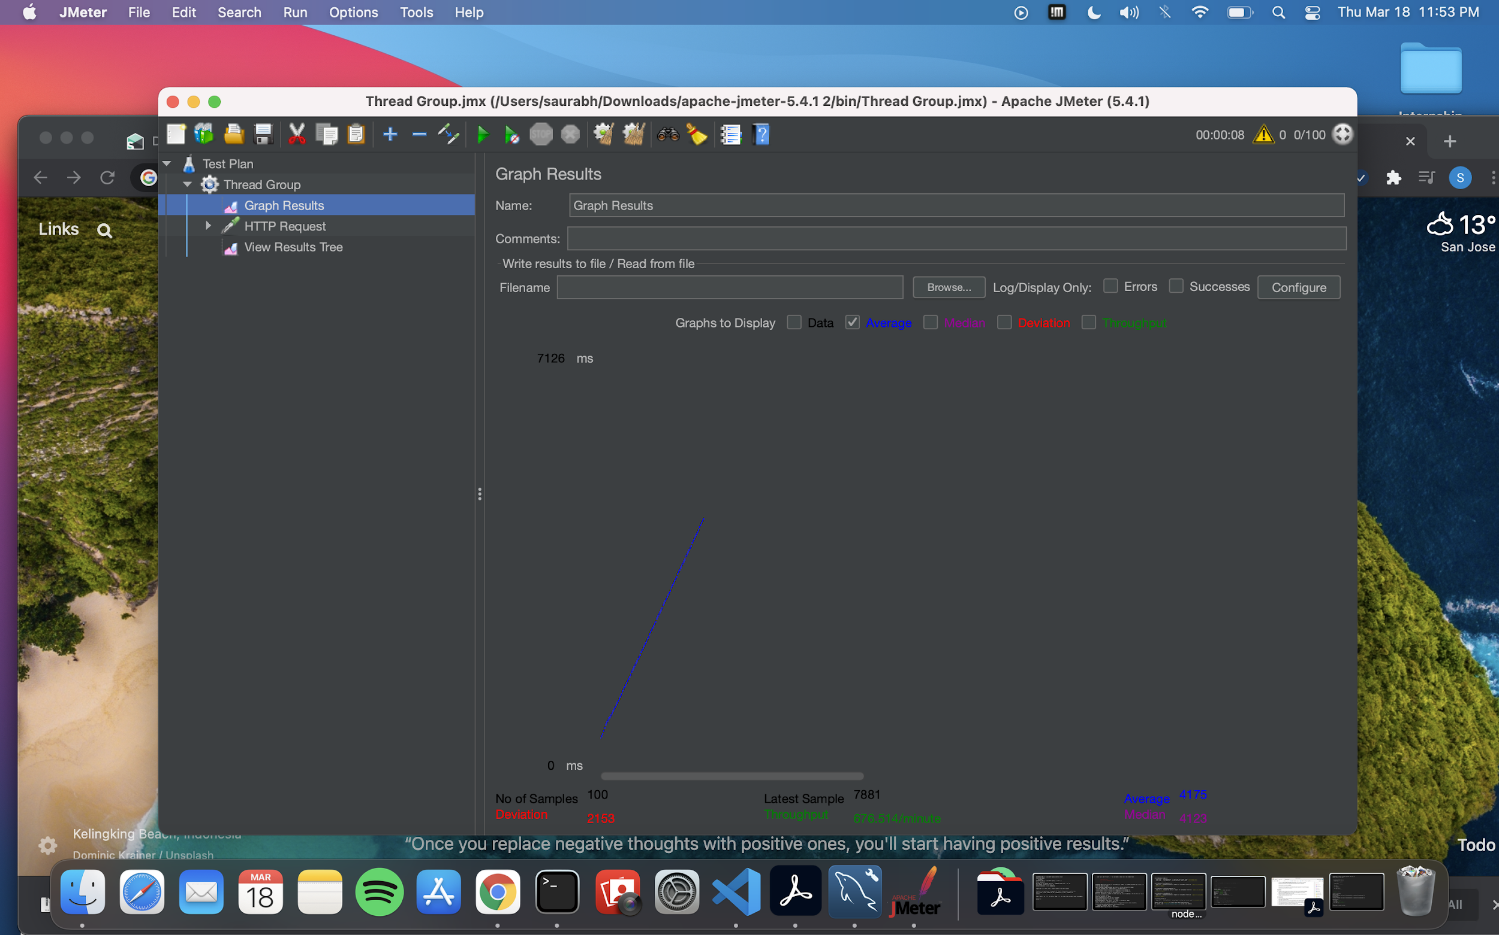

1. **With 200 concurrent users**

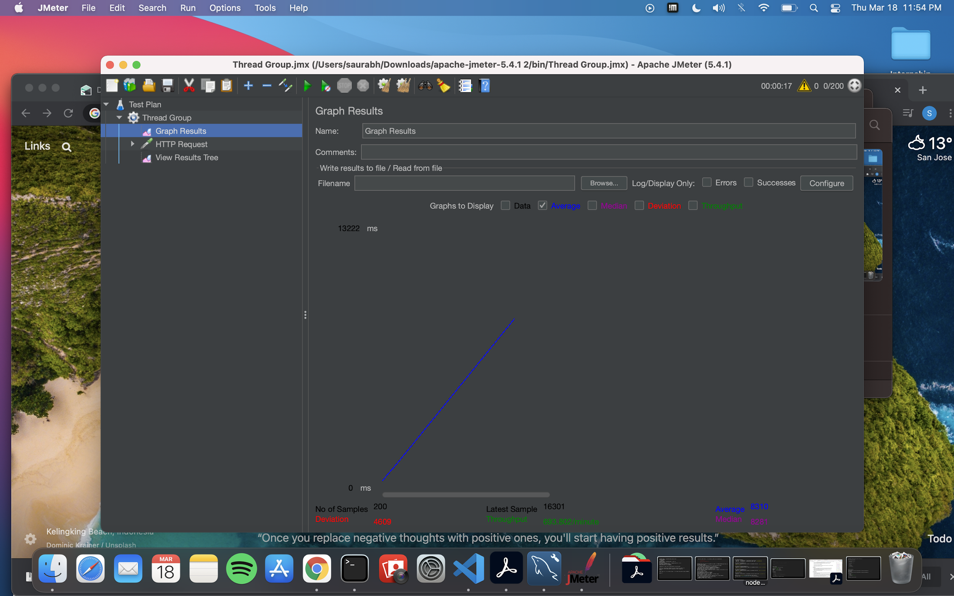

1. **With 300 concurrent users**

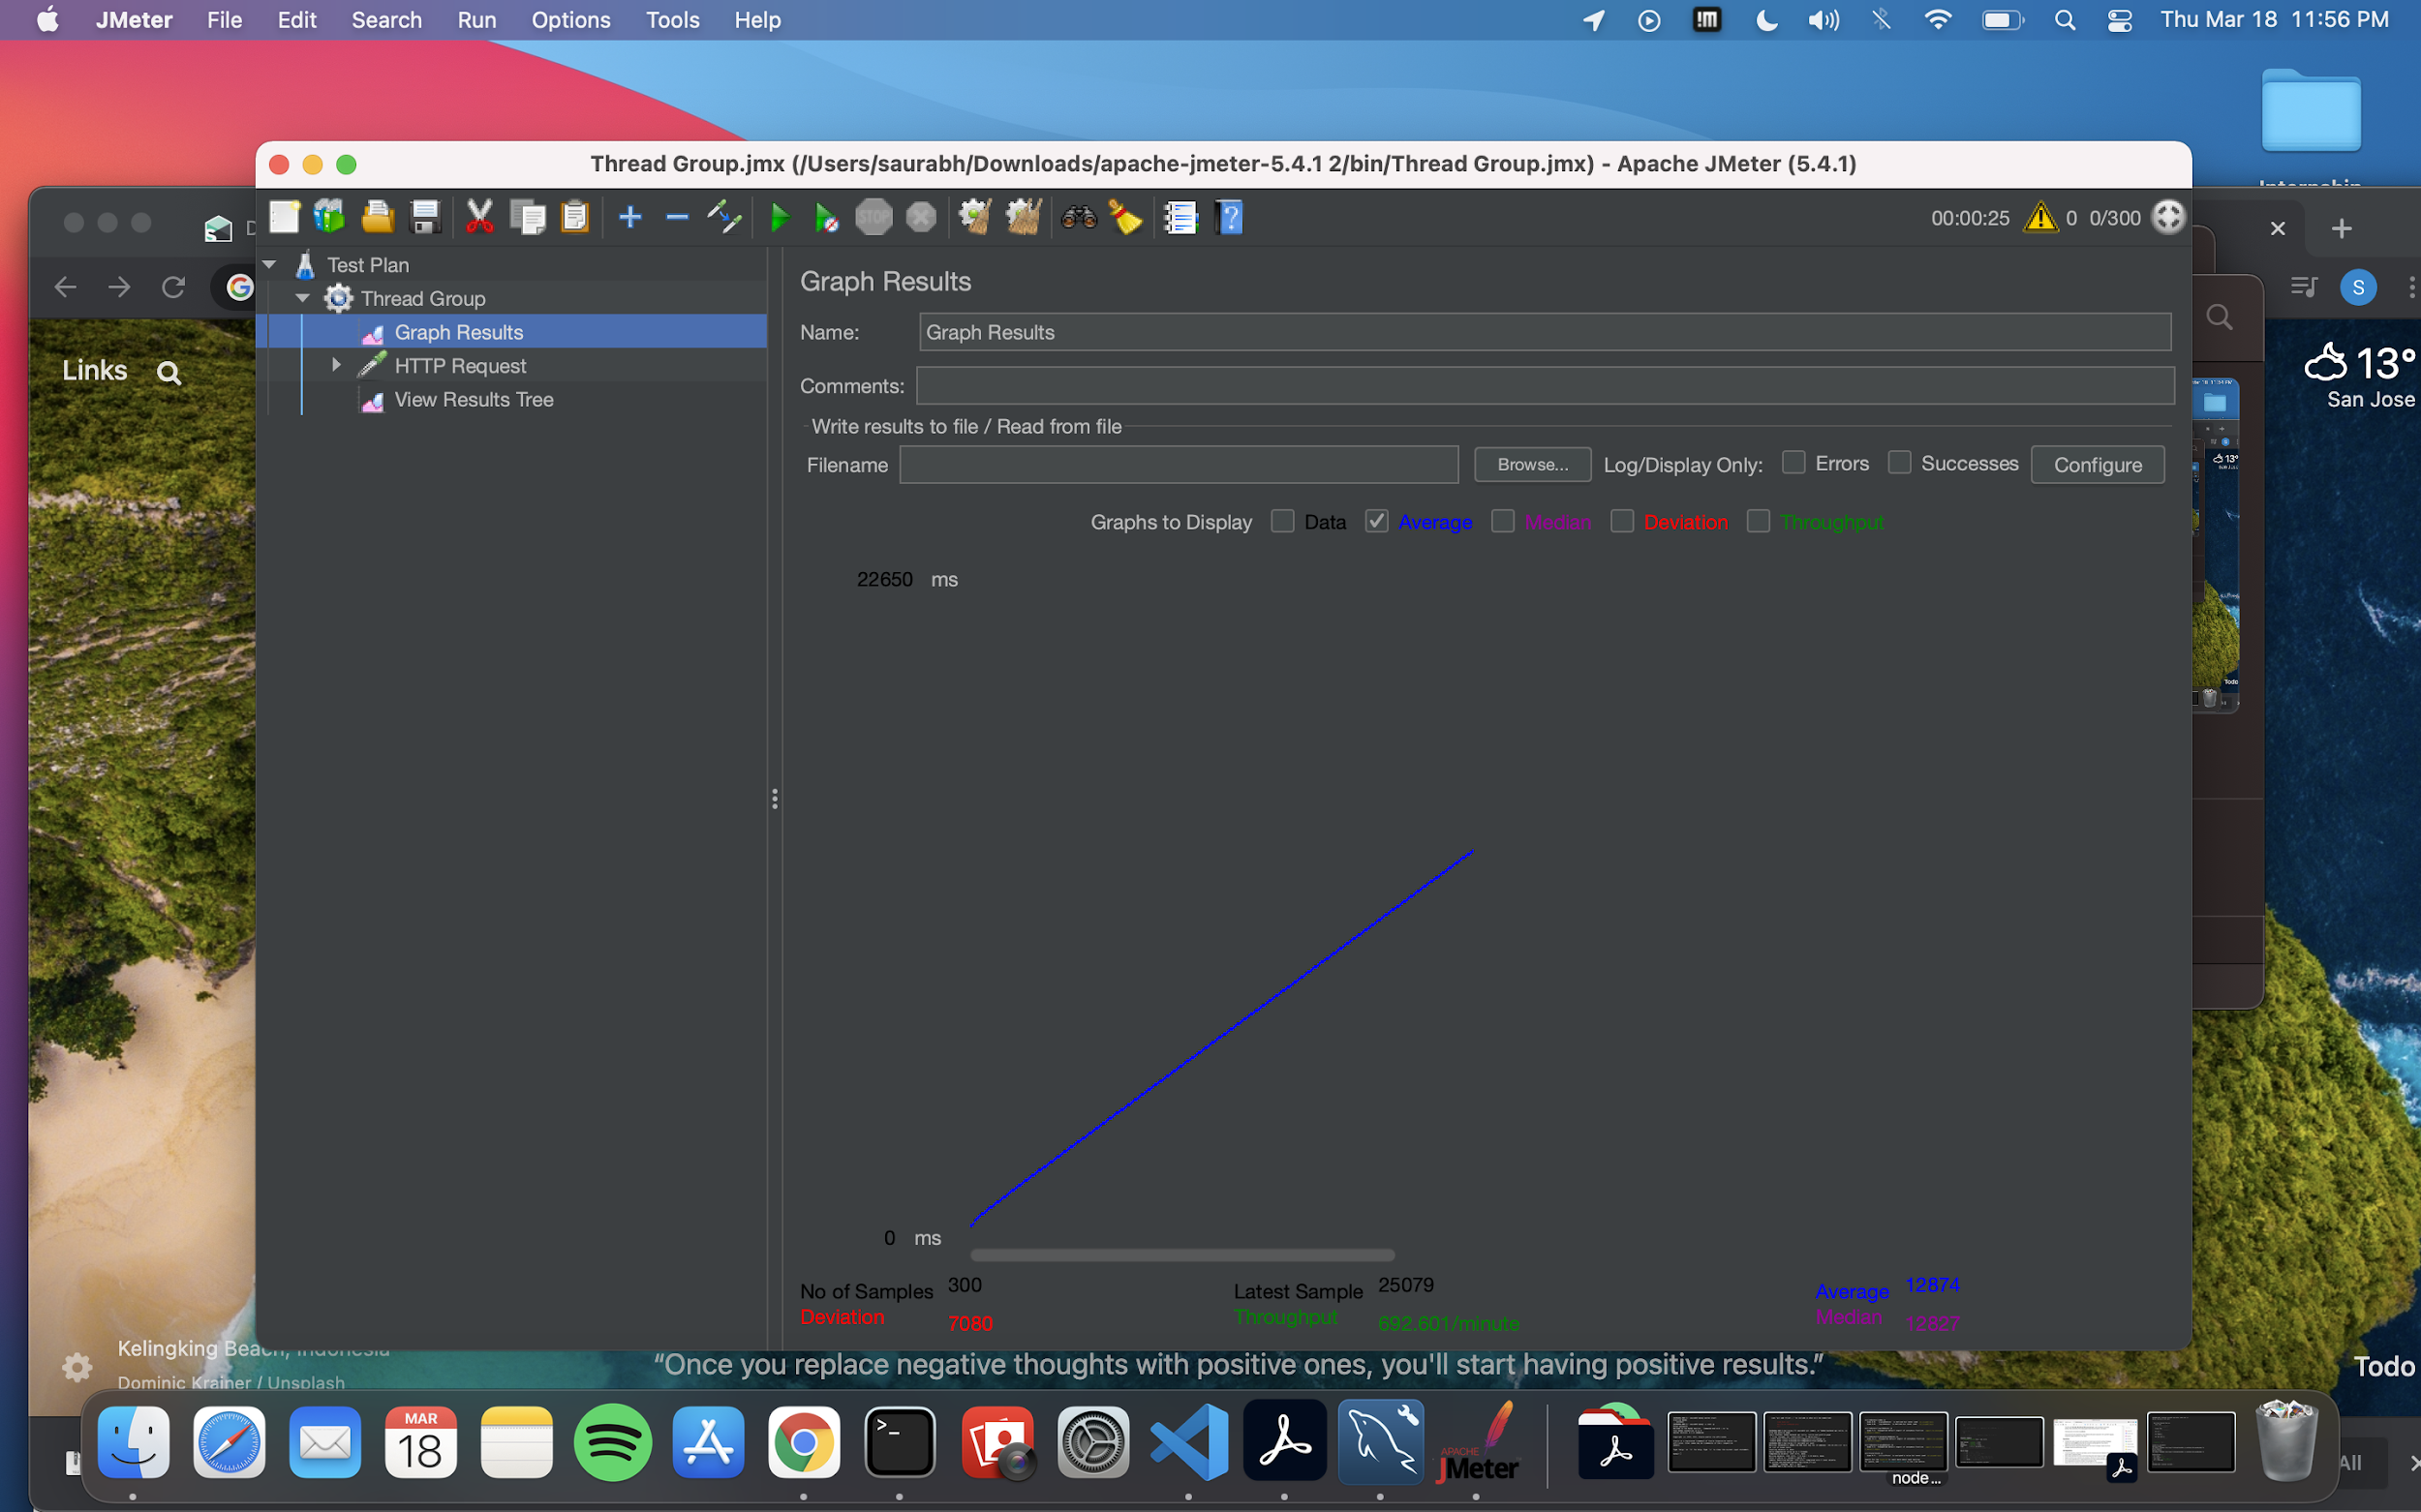

1. **With 400 concurrent users**

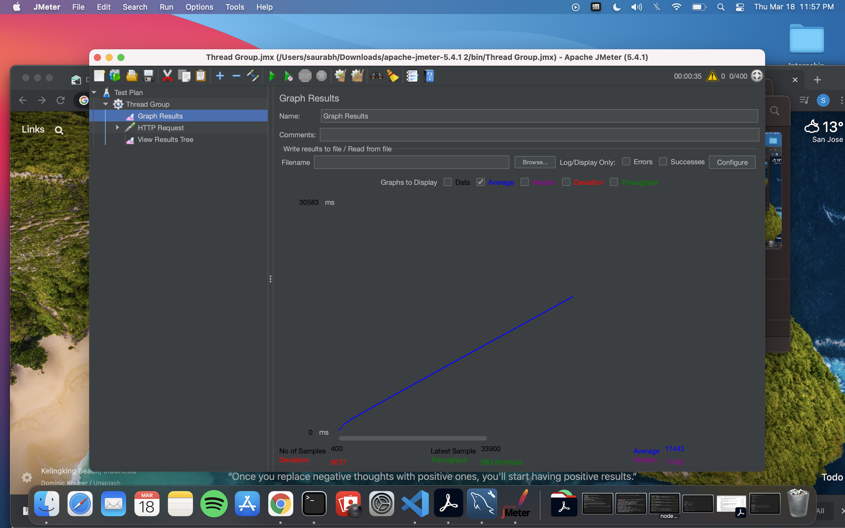

1. **With 500 concurrent users**

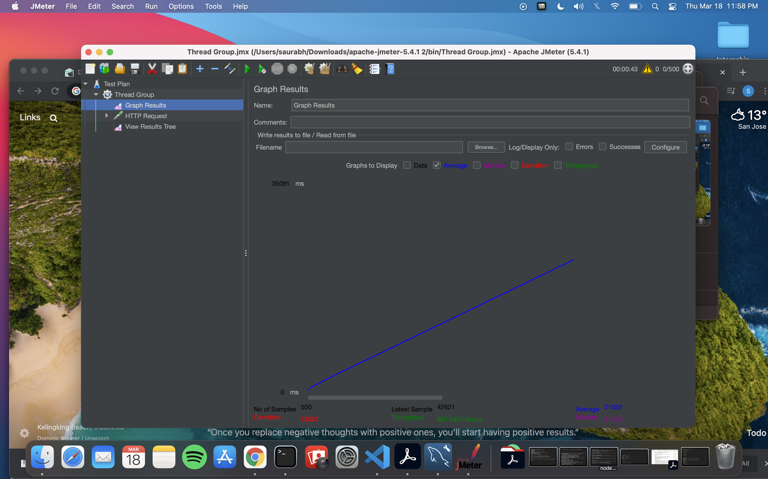

**With Pooling**

1. **With 100 concurrent users**

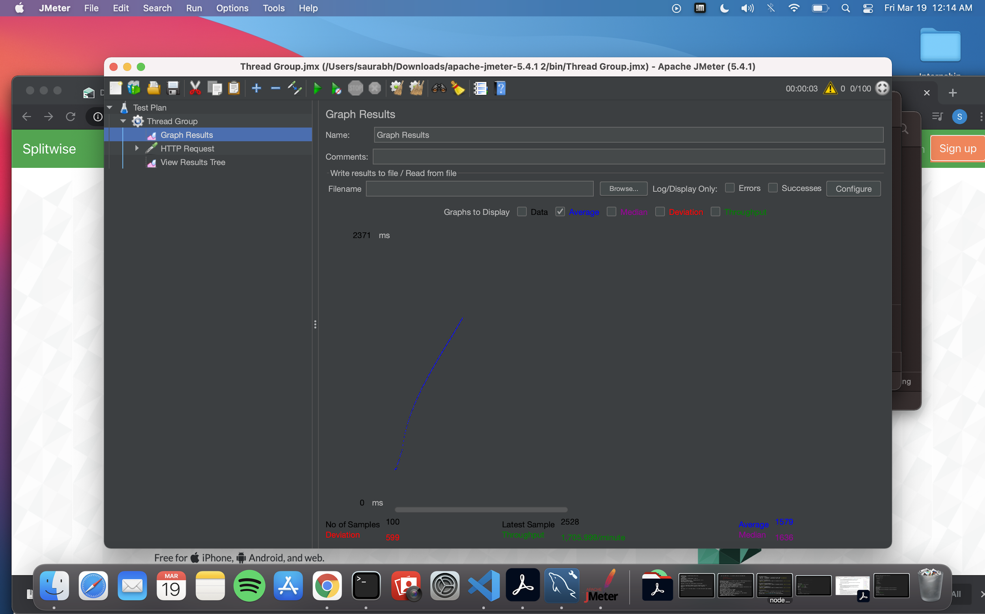

1. **With 200 concurrent users**

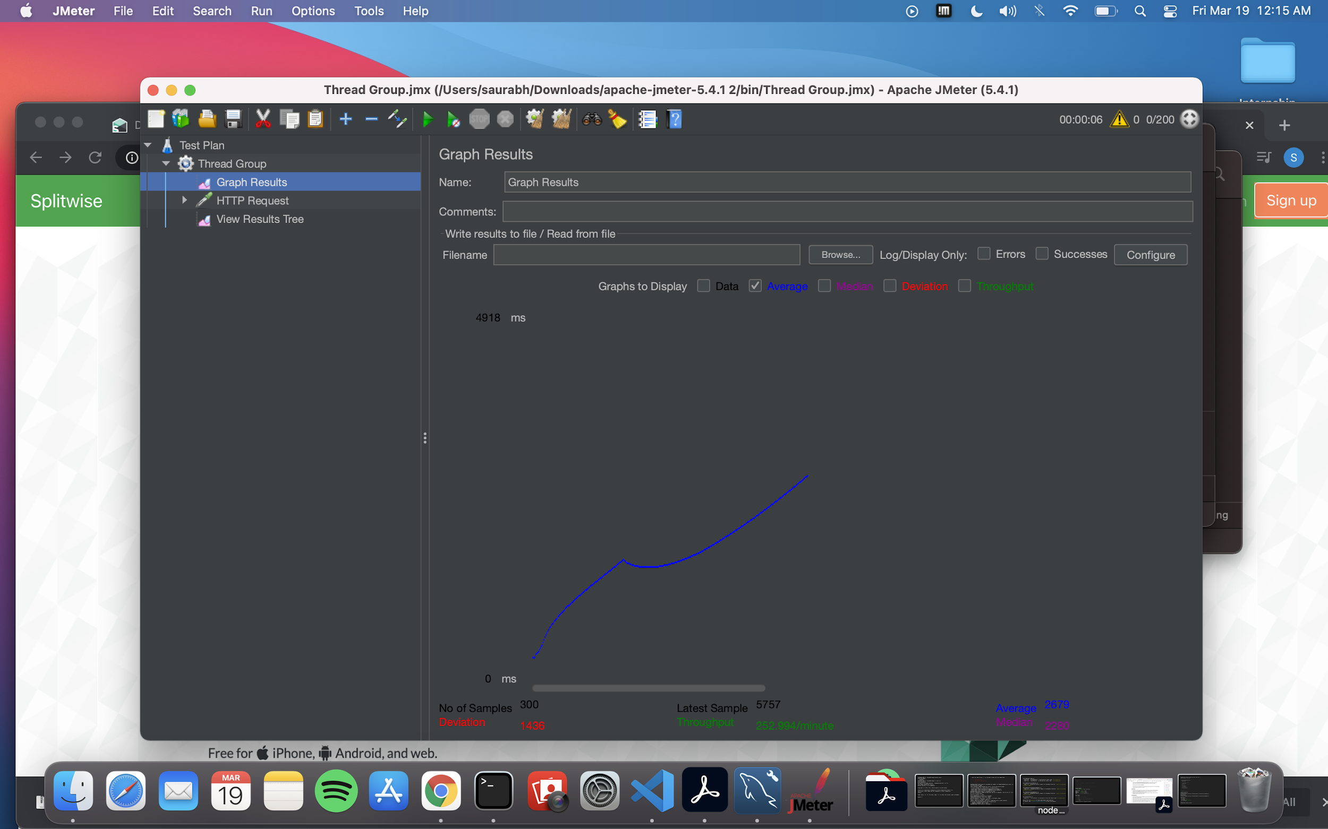

1. **With 300 concurrent users**

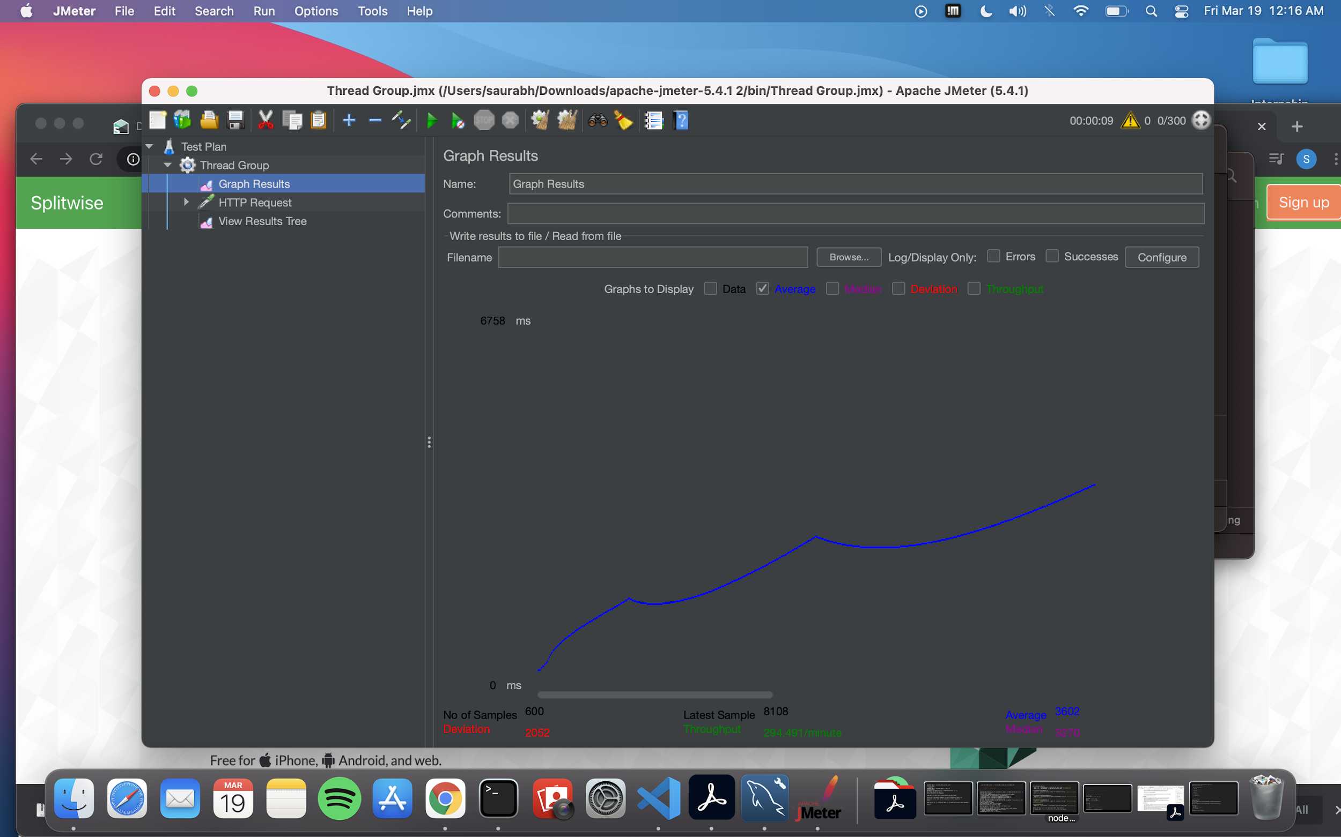

1. **With 400 concurrent users**

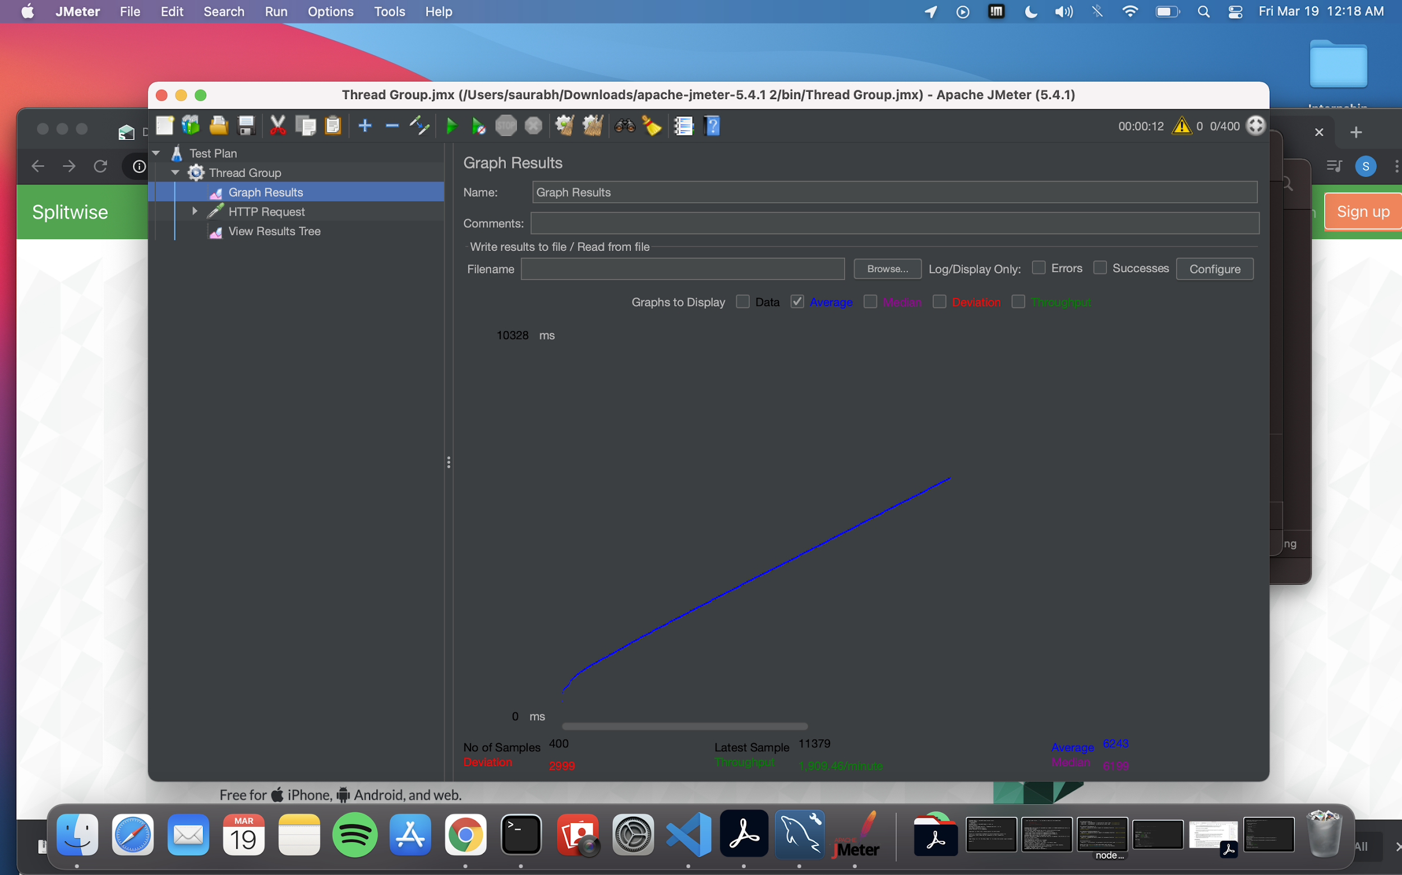

1. **With 500 concurrent users**

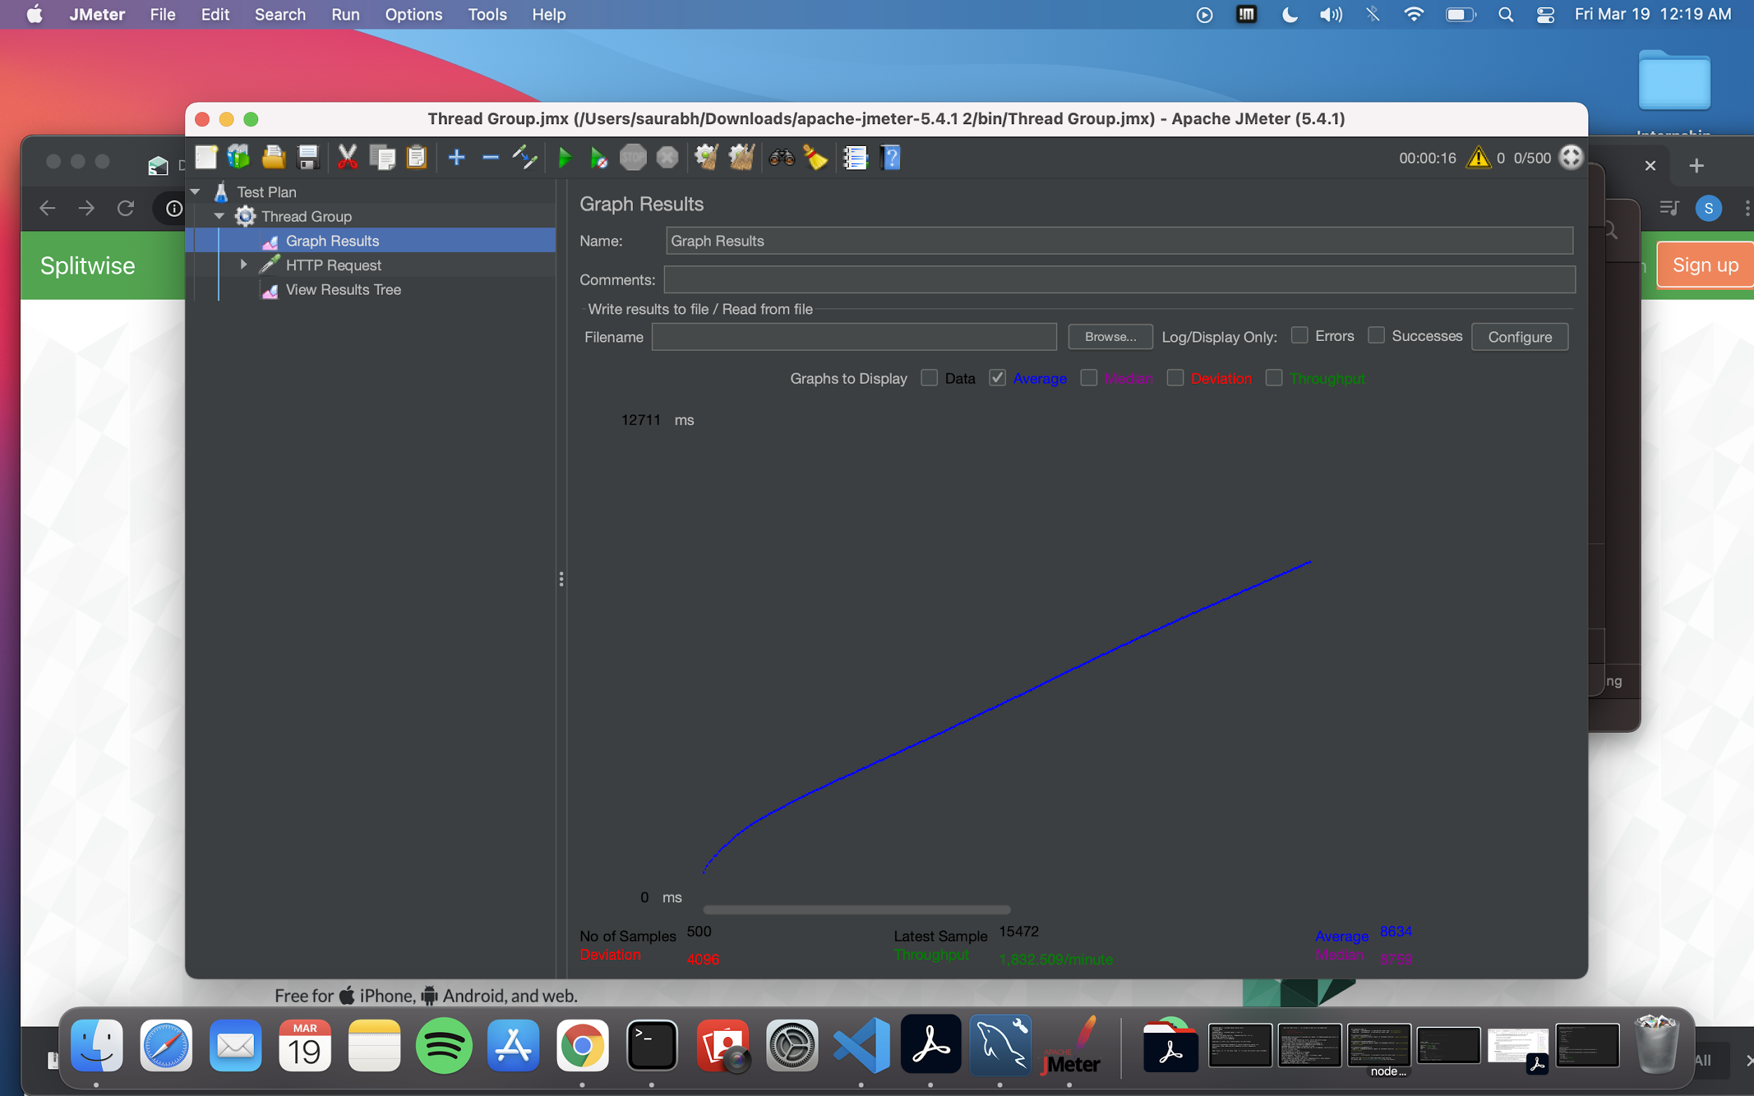

**GIT COMMIT HISTORY:**

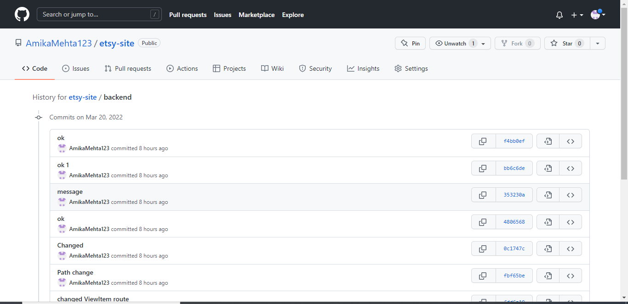

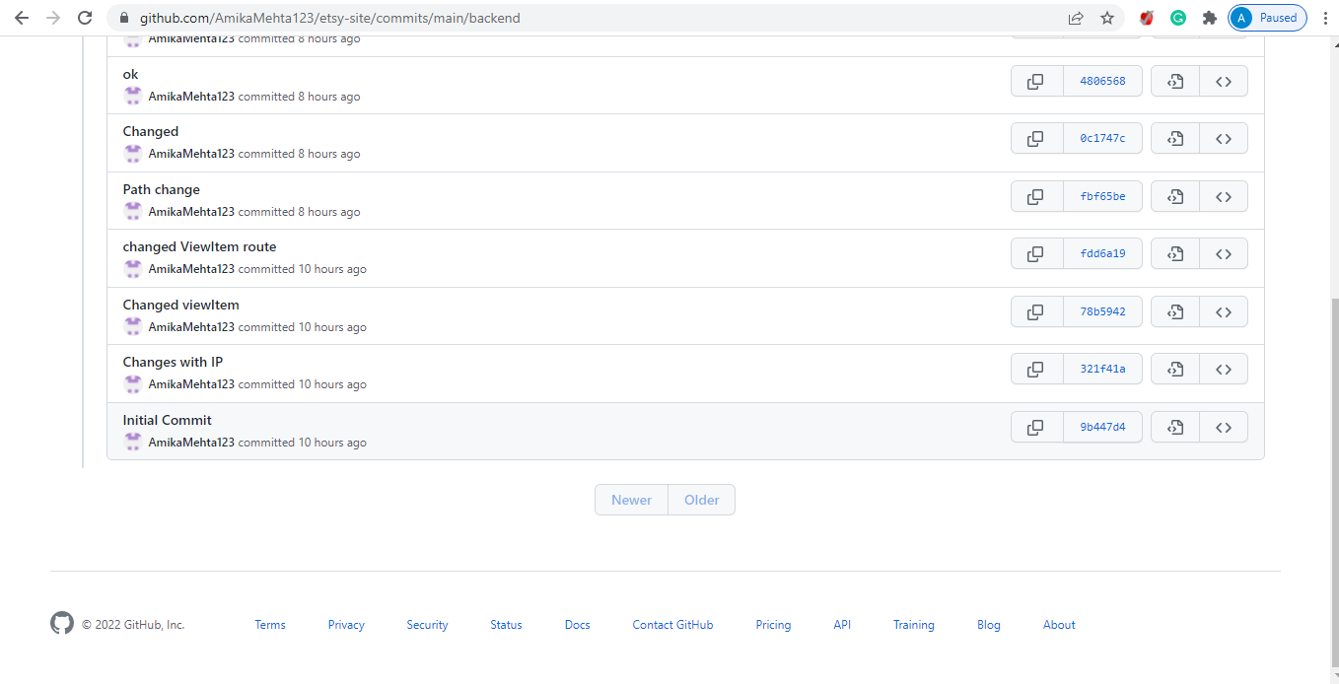

**QUESTIONS**

**1. Compare the results of graphs with and without in-built MySQL connection pooling of database. Explain the result in detail and describe the connection pooling algorithm if you need to implement connection pooling on your own.**

**Answer**

Connection pooling in the database can be done using createPool. In my application backend pooling is done as following:

const connection = mysql.createConnection({

    host     :  'etsy-database-1.cegdotowuytk.us-east-1.rds.amazonaws.com',

    user     : 'amikauser',

    password : 'amikauser',

    port : 3306,

    database : 'etsydb'

});

The efficiency of executing query increases by connection pooling. When connection pooling is not used a thread is created for every request. But when connection pooling is used instead of creating a new thread for every request a pool of thread is maintained which execute the requests. When more request come to the backend then they are maintained in a queue. Due to this the calls to the backend database are reduced.

When pooling is not used the NodeJS server crashes intermittently. When pooling is used it does not crash.

**2. What are the ways to improve SQL Performance? List at least 3 strategies. Explain why those strategies improve the performance.**

**Answer –**

1**) Avoid sub-queries and using JOINS**

When the database is large and it has lot of records then sub-queries are slower. This will delay the response time of the query. Using Join will reduce the time to get the response as in sub-queries the result of one query is passed as parameter to another query so this will slow down the response time.

**2) Removing unnecessary columns and rows before making Join**

If the tables that will be joined are large and the required columns and rows are few then the query performance will decrease. But if the rows and columns are precise then the performance of the query increases.

**3)Using SELECT fields in place of SELECT \***

When we are dealing large databases which have huge number of records then using SELECT * query will bring a lot of unwanted data. All the data is important but for some scenarios only specific data is required and doing SELECT * will bring a lot of redundant data.